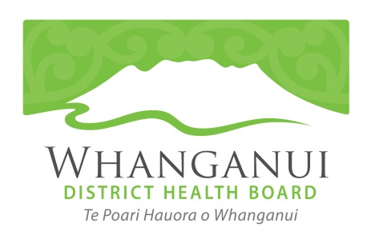
DHB excited to be Health Partner for Downer New Zealand Masters Games
07 January 2021
Whanganui District Health Board is proud to be the Health Partner for the 2021 Downer New Zealand Masters Games. This is the first year the DHB has partnered with the Games, hailed as an “important move” by WDHB chief executive Russell Simpson.
“We adopted our He Hāpori Ora - Thriving Communities strategy in late 2020 to give the WDHB and community more of a focus on health and wellbeing, rather than being the ambulance at the bottom of the cliff,” says Mr Simpson.
“Part of this strategy is putting more emphasis into prevention and community and whānau wellbeing.
“Supporting the Masters Games is a perfect fit as we know physical wellbeing can help slow down ageing, contribute to mental wellbeing and allow people to connect with each other.
“Positive ageing is a big driver of the work the district health board does, as fit and connected people are less likely to have on-going health conditions and need medical care,” Mr Simpson adds.
As well as encouraging people to participate in the Games, WDHB health professionals have organised balance and stretching and seated exercise classes at the Games Hub to complement the sports activities.
A series of seminars on health and wellbeing to arrest the ageing process will also be run at the Games Hub. Times and dates are available on the Games App from the start of February, or on
www.nzmg.com
“Everyone in our community is welcome to attend these events, not just participants,” says Mr Simpson.
WDHB physiotherapists will also be on the sidelines of some sports to assist Games participants with injury and injury prevention.
Games manager Rachel O’Connor is excited about the Downer New Zealand Master Games and Whanganui District Health Board partnership.
“The district health board’s plans for the partnership is innovative and fits the Games philosophy perfectly,” says Rachel.
“Staying active, no matter what age, is vital to our wellbeing. With a wide range of sports on offer at the Games, there is something for everyone and the WDHB’s seminars and balance classes will take fitness and recovery far beyond the 10 days of the Games. It’s advice and support for life.”

For further media comment please contact WDHB Communications Manager Mark Dawson on 021 246 8126.

