PARTICPANT INFORMATION – NZMG CYCLOCROSS
We’re stoked to bring Summer Cyclocross (CX) to the NZMG for the first time. Bring your cheerleading team (we’ll provide the bells) for a adrenalin pumping and entertaining evening on two wheels…. right next to our Awa!

Date:
Sunday 5 February 2022
Venue:
Kowhai Park – Anzac Parade, Whanganui
Times:
Event starts @ 4pm
Fees:
Individual Events: $20 per rider, late entries + $5
Team Challenge: $10 per rider, later entries + $5
Entries Close:
Friday 27 January 2023
Contact:
cath@cyclesport.co.nz
Minimum Age:
30+ at the first day of competition
Race Pack:
As part of your entry, you’ll receive your own bike number plate, some noise making devices and we’ll crank up the barbie post racing.
Categories/Groups:
- Team CX Challenge
- Social CX
- eBike CX
- Competitive CX
Length/Minutes | Event | Notes
Laps TBC | Team CX Challenge | 2-4 per team, minimum laps per rider
30min | Social CX Grades + eBikes* | M/F 30-39, 40-49, 50-59, 60-69, 70+
40min | Competitive CX Grades* | M/F 30-39, 40-49, 50-59, 60-69, 70+

* Depending on entries grades may be split or started in waves

Proposed Event Schedule:
The schedule will be finalised closer to the event and is subject to change during the event. No event will start earlier than advertised.
Time: | Event | Notes
4.00pm | Course Open for Warm Up | Awa CX from 3pm for Kids!
4.30pm | Team CX Challenge | 2-4 per team, minimum laps per rider
5.00pm | Social CX Grades + eBikes* | M/F 30-39, 40-49, 50-59, 60-69, 70+
5.40pm | Competitive CX Grades* | M/F 30-39, 40-49, 50-59, 60-69, 70+
6.20pm | Presentations & BBQ

Course Map:
Very draft to give you an idea of what’s install! Stay tuned for further details including parking, registration, and facilities.
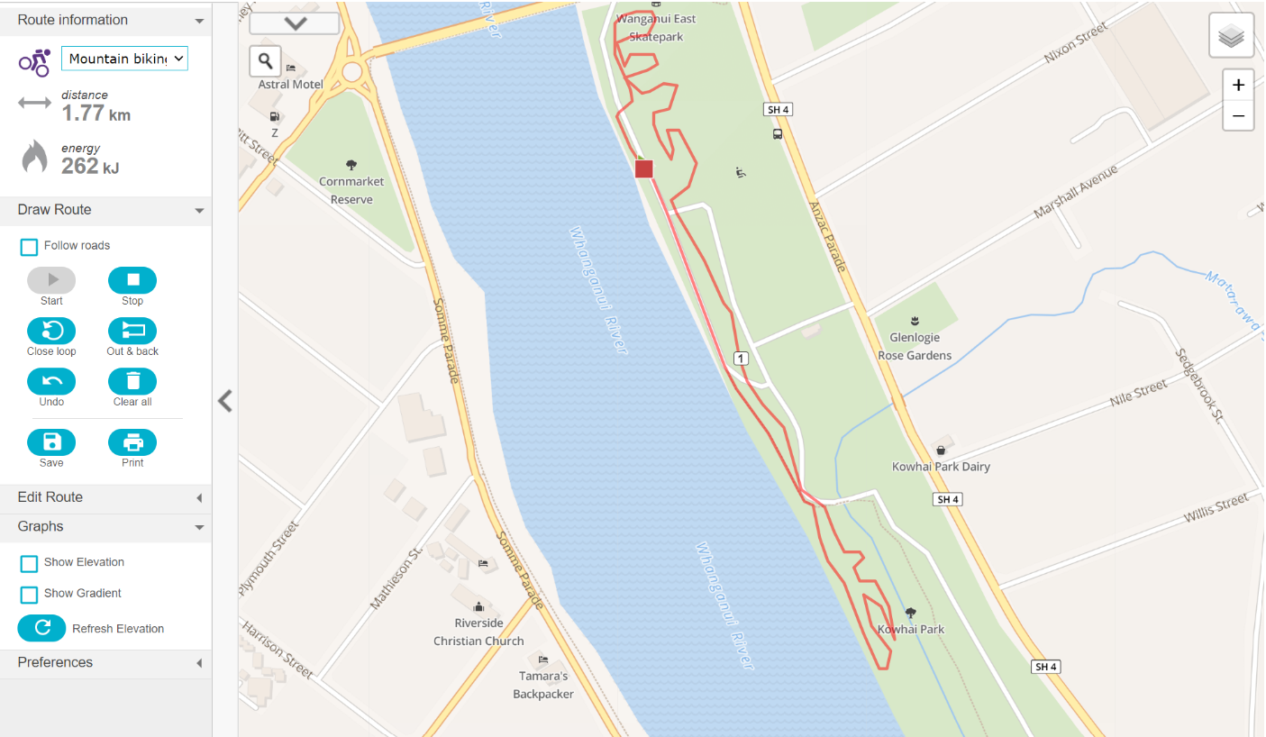
On the Day:
- Arrive early using the designated parking spots
- Follow the event marshals’ instructions if crossing the course
- Sign in at the registration tent so we know who’s on the start line. On-the-day entrants depend on space availability
- Make sure your number is attached securely
- Tents and bike parking will be set up in the designated area
- Listen to the MC for opening of the course for warm up/familiarisation
- Your event will be called to the start line approx. 5mins before your start for the official briefing
Equipment Requirements:
- Bicycles shall be outfitted as per the road code and must have two working brakes, one front and one rear
- Bicycles must be mechanically sound
- Dropped or straight handlebars are permitted
- Bar ends and aero bars are not permitted
- Fixed wheel bicycles are not permitted
- Electric Bikes are permitted in the social grade
- Mountain bikes, hybrid bikes, and single speeds are permitted as long as they meet the requirements above
- NZ Safety approved helmets must be worn and always fastened during warmup, racing, and warm down.
Conditions of Entry:
1. I agree to comply with the racing rules which this event is being run under.
2. I am aware of the dangers and compete in the event at my own risk.
3. I have no known medical conditions that would prevent me from participating safely and I have an appropriate physical condition to participate in the event.
4. The organisers of this event have done their best to make the event as safe as possible, considering Park Traffic Management regulations and the fact that the organisers cannot control every eventuality.
5. If I am involved in an accident, I will not seek to blame or make a claim against the organisers. Nor will I assist anyone else in making such a claim.
6. If I have any concerns with the race organisation, I will raise them with the organisers first.
7. I agree to receive information from event organisers by email.
8. The event organisers reserve the right to alter or cancel the event should weather or other circumstances prevent this from being a safe event.

FAQ’s
What is Cyclocross?
It’s a form of bicycle racing which incorporates mixed terrains, different surfaces and obstacles in a short circuit completed multiple times. Riders can dismount and push, lift or even run with their bikes. It tests all aspects of the rider’s physiology and with spectators close to the action in a party like atmosphere it is a heap of fun!
Do I need a special bike to take part?
No, you don’t but your bike will need to fit the equipment requirements outlined above and be suitable to navigate the mixed terrain and different surfaces.
How does the Team CX Challenge work?
Grab 2-4 mates, work mates, your partner or family crew, throw on a sweet outfit (that won’t get caught in your spokes!) and complete a set number of laps of the course. How you configure completing the laps is up to you but there will be a minimum required per rider. Bring it on!
Should I enter the Social or Competitive Grade?
If you’ve ridden CX before, have a CX/Gravel bike and you like your legs to do the talking we suggest you enter the competitive grades.
If you’re a first time CX’er, dusting off the MTB bike for the Master’s Games, like to dress up or like to ‘whoop’ the crowd as you navigate the course the social grades are for you.
Do I need to wear lycra?
No, you don’t (in fact we’d prefer it if you didn’t…wink!!). We encourage you to dress to your teams motivation and show your bling (safely) in the social grades… there will be prizes.
Can I do both the Team Challenge & Individual Event?
Absolutely, you can even ride different bikes & don a different kit if you like!
How long am I racing for?
The Team Challenge will be over a set number of laps. You’ll need to keep count of your teams laps.
The Individual Events will be based on time – 30mins for Social and 40mins for Competitive. The event officials will ring the bell so you know when your final lap of the course begins.
How does the start work?
Everyone starts together bunched in their age groups with a minimum of one foot on the ground. The starter will count you down. Depending on entry numbers we may stagger age group starts.
Will I get lost on the course?
Let’s hope not (if you need up in the river you’ve taken a wrong turn)! The majority of the course will be taped off with marshals stationed around the course. The course will also be open for warm up/familiarisation prior to the events.
What happens if I get lapped?
You keep riding! Just remember to keep left to allow faster riders to pass. You will finish on the same lap as the leading rider in individual events.
What happens if I have a mechanical during my event?
There will be a designated ‘pit’ area at the start/finish where you can leave your own spare equipment or tools. Your supporters can also help you on the course, just be aware of other riders. If you’re headed to the pits please don’t ride backwards on the course.

